# 

# TOURSIM PLACES IN INDIA USING

## FRONTEND DEVELOPEMENT

## INTRODUTION:

* India is a country that attracts millions of tourists every year and is considered one of the most popular tourist destinations in the world. These visitors are attracted to its natural beauty and cultural heritage. It has many historic sites as well like the Taj Mahal, Golden Temple, Red Fort, etc. With so much to offer, it’s no surprise that tourism is one of the main sources of revenue for the country!

CODE: <!DOCTYPE html>

<html>

<head>

<title>Tourist</title>

<meta charset="utf-8">

<meta name="viewport" content="width=device-width, initial-scale=1">

<link rel="stylesheet" href="https://maxcdn.bootstrapcdn.com/bootstrap/3.4.1/css/bootstrap.min.css">

<script src="https://ajax.googleapis.com/ajax/libs/jquery/3.6.0/jquery.min.js"></script>

<script src="https://maxcdn.bootstrapcdn.com/bootstrap/3.4.1/js/bootstrap.min.js"></script>

</head>

<body>

<div class="topnav">

<a class="active" href="project2.html" target="_blank">Home</a>

<a href="#">TOP10</a>

<a href="feedback.html" target="parent">FeedBack</a>

<a href="about.html">About Us</a>

<input type="search" placeholder="search..." style="color: blueviolet;">

  </div>

<h1 style="text-align: center;color: darkred;" > Top 25 tourist places in india</h1>

<p style="text-align: left; font-size: 17px; color: black;">India is home to a wide range of cultures and faiths. The seventh-largest country globally, India stretches from the Himalayan highlands to Kerala's tropical beauty, from the sacred Ganges to the Thar Desert. Mountains, Monuments, Beaches, Tropical islands, Forests, Hill stations, Temples, and many World Heritage Sites are among the many tourist attractions in India that will enchant Tourist </p></div></body></html>

<ol>

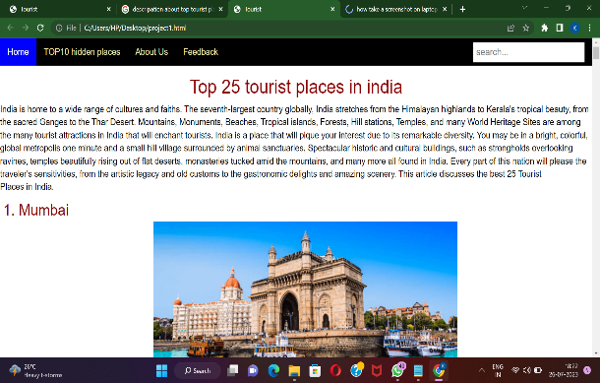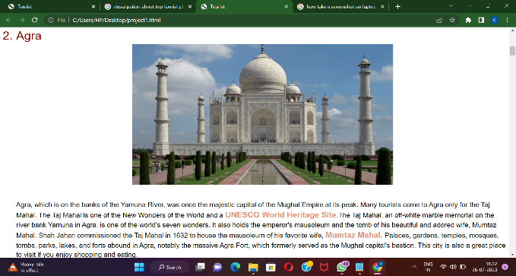OUTPUT:

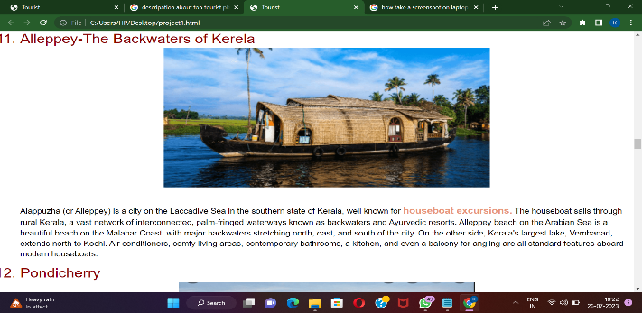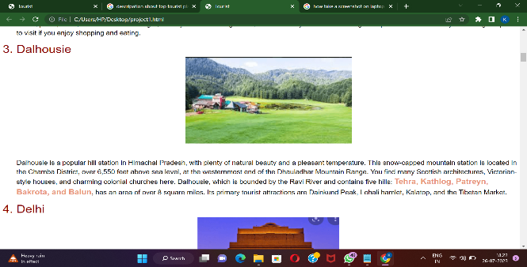

## TOP10 HIDDEN PLACES IN INDIAN:

## CODE:

<!DOCTYPE html>

<html>

<head>

<title>Tourist</title>

<meta charset="utf-8">

<meta name="viewport" content="width=device-width, initial-scale=1">

<link rel="stylesheet" href="https://maxcdn.bootstrapcdn.com/bootstrap/3.4.1/css/bootstrap.min.css">

<script src="https://ajax.googleapis.com/ajax/libs/jquery/3.6.0/jquery.min.js"></script>

<script src="https://maxcdn.bootstrapcdn.com/bootstrap/3.4.1/js/bootstrap.min.js"></script>

</head>

</style>

<body>

<h1 style="text-align: center;color: darkred;" class="blink" >Top 10 Hidden places in india</h1>

<p style="text-align: left; font-size: 17px; color: black;"></p>

<ol>

<li style="font-size: 30px ;color: darkred;">Laitmawsiang,Meghalaya</li>

<center><img src="https://static2.tripoto.com/media/filter/nl/img/15546/TripDocument/1458725059_nature_scenic_landscape_meghalaya_laitmawsiang_india_july_2011.jpg" height="380px",with="380px"></center><br>

<br>

<p style="font-size:24px; color:black;">This small village located in Khatarshnong Laitkroh Block of East Khasi Hills, is the perfect hideout for people hungry for isolation in the lap of nature.</p>

<li style="font-size: 30px ;color: darkred;"> Chettinad Palace,Rajasthan</li>

<center><img src="https://static2.tripoto.com/media/filter/nl/img/15546/TripDocument/1458725163_chettinad_palace_in_karaikudi.jpg"height="380px",with="380px"></center><br>

<br> <a href="project1.html">

<button type="button"class="button1">back</button>

</a>

</ol>

</body>

</html>

## OUTPUT:

## FEEDBACK FROM:

## CODE:

<!DOCTYPE html>

<html lang="en">

<head>

<title>Bootstrap Example</title>

## FEEDBACK FROM:

## CODE:

<!DOCTYPE html>

<html lang="en">

<head>

<title>Bootstrap Example</title>

<meta charset="utf-8">

<meta name="viewport" content="width=device-width, initial-scale=1">

<link rel="stylesheet" href="https://maxcdn.bootstrapcdn.com/bootstrap/3.4.1/css/bootstrap.min.css">

<script src="https://ajax.googleapis.com/ajax/libs/jquery/3.6.0/jquery.min.js"></script>

<script src="https://maxcdn.bootstrapcdn.com/bootstrap/3.4.1/js/bootstrap.min.js"></script>

<style>

body{

background-color:bisque;

}

.SUBMIT {

background-color: #4CAF50;

border: none;

color: white;

padding: 15px 32px;

text-align: center;

text-decoration: none;

display: inline-block;

font-size: 16px;

margin: 4px 2px;

cursor: pointer;

}

</style>

</head>

<body>

<div class = "page-header">

<!-- <h1> This is a heading</h1> -->

</div>

<div class = "container">

<br><br><br><br><br><br>

<div class = "jumbotron">

<h2>Customer Feedback Form</h2>

<br>

<div class = "form-group">

<label>Name : </label>

<input type = "Name" class = "form-control"

placeholder = "enter your name" id = "Name">

</div>

<div class = "form-group">

<label>Remarks :</label>

<input type = "review" class = "form-control"

placeholder="enter description" id = "review">

</div>

<a href="project1.html">

<input type="SUBMIT" class="back" value="back">

</a>

<a href="thank.html">

<input type="SUBMIT" class="SUBMIT" value="SUBMIT">

</a>

</div>

</body>

</html>

## OUTPUT: